Creating table1

CREATE TABLE Departments (

DepartmentID INT,

DepartmentName VARCHAR(50)

);

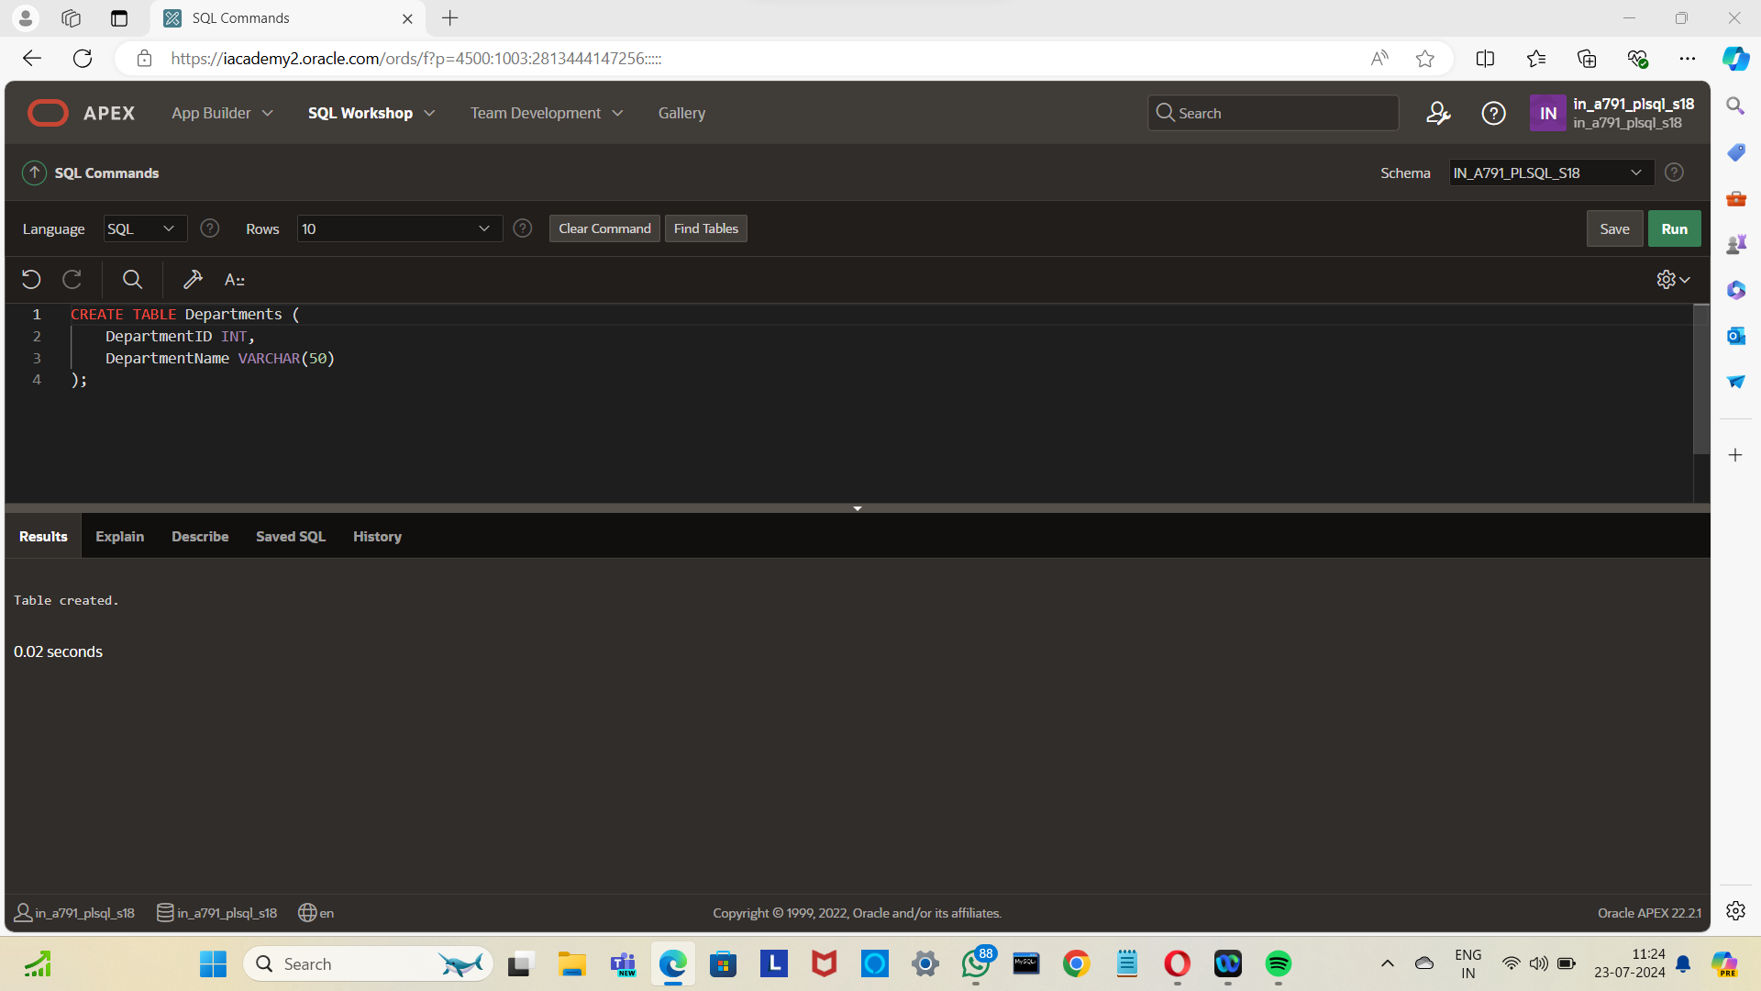

Inserting values

INSERT INTO Departments VALUES

(1, 'HR');

INSERT INTO Departments VALUES

(2, 'Finance');

INSERT INTO Departments VALUES

(3, 'Marketing');

INSERT INTO Departments VALUES

(4,'IT');

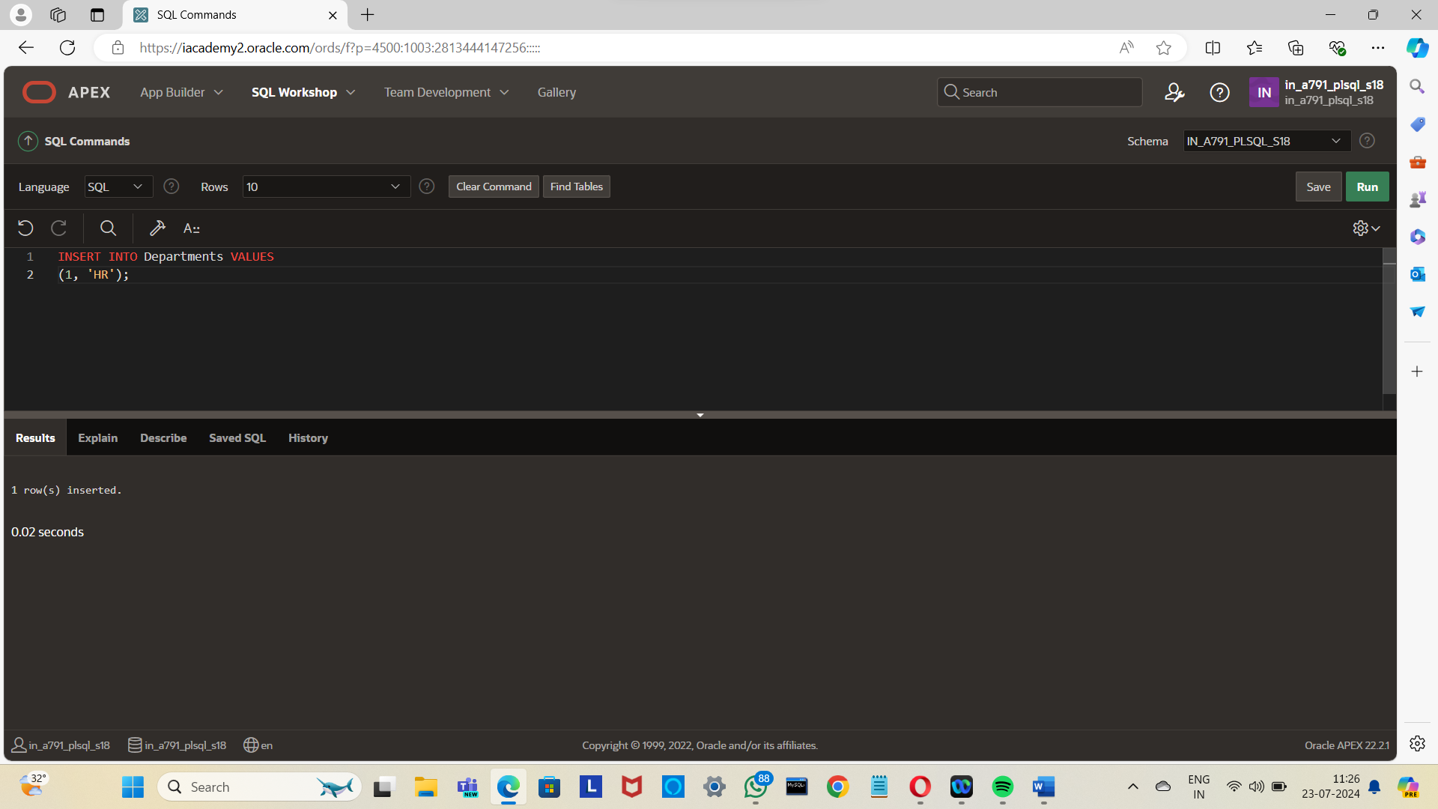

Creating table 2

CREATE TABLE Employees (

EmployeeID INT,

EmployeeName VARCHAR(50),

DepartmentID INT,

Salary DECIMAL(10, 2)

);

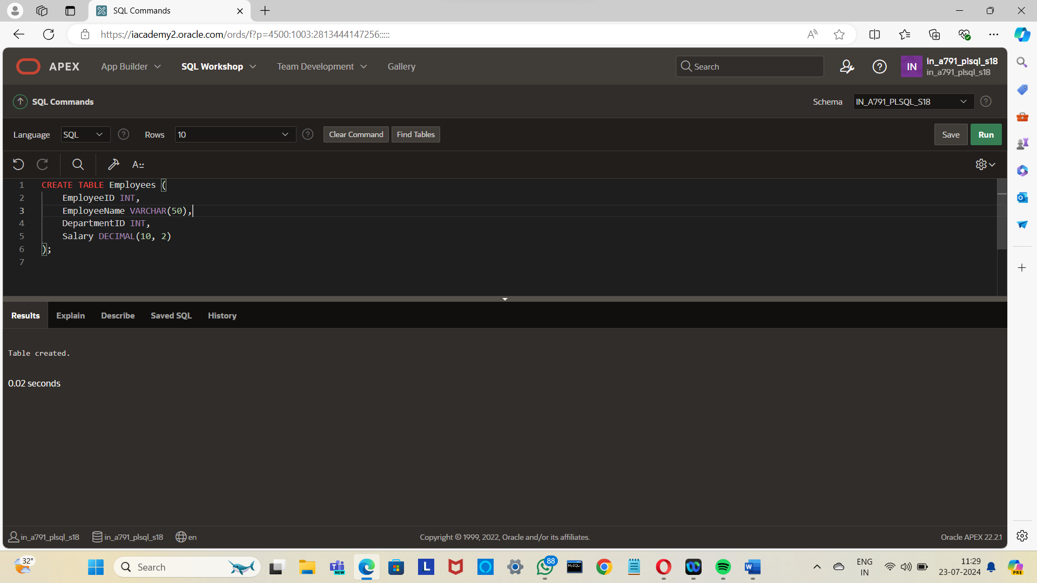

Inserting values

INSERT INTO Employees VALUES

(1, 'John Doe', 1, 50000.00);

INSERT INTO Employees VALUES

(2, 'Jane Smith', 1, 55000.00);

INSERT INTO Employees VALUES

(3, 'Mike Johnson', 2, 60000.00);

INSERT INTO Employees VALUES

(4, 'Emily Davis', 2, 58000.00);

INSERT INTO Employees VALUES

(5, 'David Brown', 3, 62000.00);

INSERT INTO Employees VALUES

(6, 'Sarah Lee', 3, 61000.00);

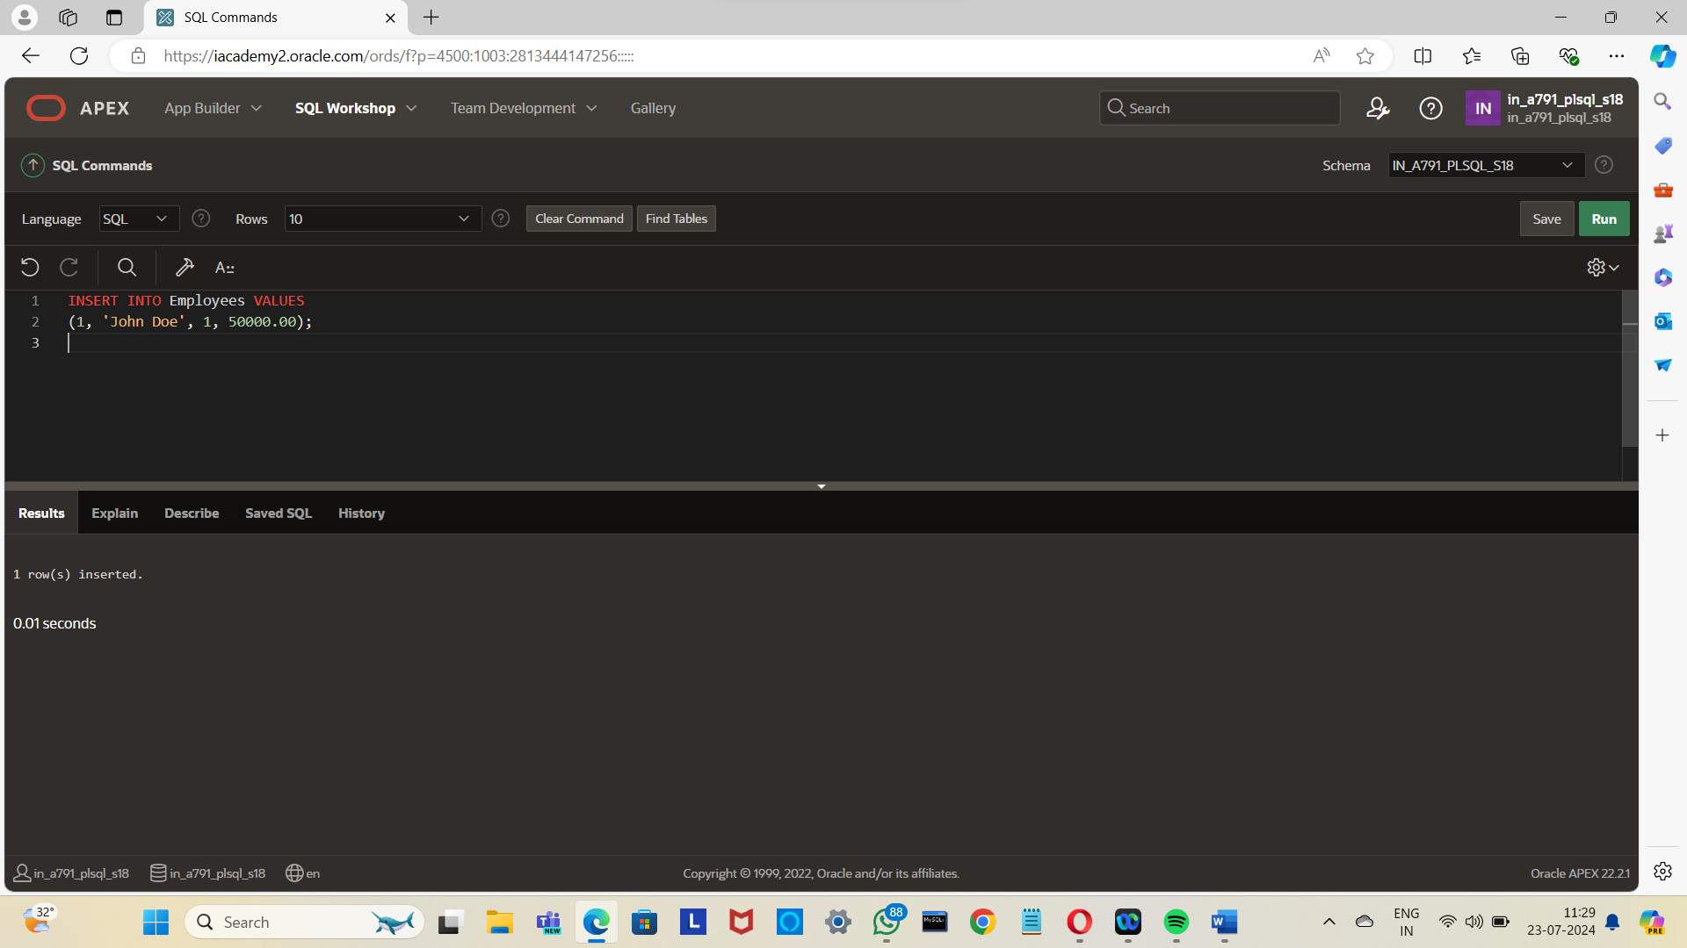

Finding average salary

SELECT

d.DepartmentID,

d.DepartmentName,

(SELECT AVG(e.Salary)

FROM Employees e

WHERE e.DepartmentID = d.DepartmentID

) AS AvgSalary

FROM Departments d

ORDER BY AvgSalary DESC;

s